

Measuring the half-life of protactinium

Demonstration
Measuring the half-life of a radioactive isotope brings some of the wonder of radioactive decay into the school laboratory. Students can witness one element turning into another and hear (or see) the decrease in the radiation that it gives out as it transmutes.
This demonstration uses a “protactinium generator” to show the exponential decay of protactinium-234, a granddaughter of uranium. It has a half-life of just over a minute, which gives students the chance to measure and analyse the decay in a single lesson.

Apparatus and materials
- Holder for Geiger–Müller (G–M) tube
- G–M tube, thin window
- Scaler
- Stopclock
- Retort stand, boss and clamp
- Protactinium generator
- Ratemeter (optional)

Technical notes
Preparation of the protactinium generator
It is now possible to purchase the chemicals already made up in a sealed bottle. One supplier is TAAB Laboratories Equipment Ltd, 3 Minerva House, Calleva Park, Aldermaston, RG7 8NA (tel 0118 9817775), but you can make your own if you prefer.
These quantities make a total volume of 20 cm³. You can scale them up if you have a larger bottle. (A 30 ml bottle has a capacity of about 35 ml, so there is still room to shake the solution if the total volume is 30 ml.)
1) Dissolve 1 g of uranyl nitrate in 3 cm³ of water. Wash it into a small separating funnel or beaker with 7 cm³ of concentrated hydrochloric acid.
2) To this solution, add 10 cm³ of iso-butyl methyl ketone or amyl acetate.
3) Shake the mixture for about five minutes, then run the liquid into the polypropylene bottle and firmly screw down the cap. It can help to shield the lower half of the bottle with some lead.
4) Place the bottle in a tray lined with absorbent paper.
Once you have made the protactinium generator, you can store it with other radioactive materials, taking care to follow your school code of practice and local rules (see the Managing radioactive materials in schools guidance note).
A polypropylene bottle is preferable to polythene because it is somewhat more resistant to attack by the acid and ketone. Nevertheless, polythene bottles can be used, provided that no attempt is made to store the liquid in them for more than a few weeks.
The organic layer that separates out contains the protactinium-234. This decays with a half-life of 68 s.
There is an alternative to protactimium. A new, effective and extremely low hazard system for measuring half-life is available from Cooknell Electronics Ltd, Weymouth, DT4 9TJ. This uses fabric gas mantles designed for camping lights. Each mantle contains a small quantity of radioactive thorium. More details are available on the Cooknell Electronics website.

Safety
See the Managing radioactive materials in schools guidance note.
To limit the risk of radioactive liquids being spilt, there should be special instructions in the local rules for handling (and preparing) this source.
Read our health and safety statement.

Procedure
a Support the G–M tube holder in a clamp so that the tube is facing downwards towards the neck of the bottle.
b Allow the bottle to stand for at least 10 minutes. Take the background count by running the counter for at least 30 s. This is done with the bottle in position, because some of the count will come from the lower layer. You can do this before the experiment or some time after it has finished.
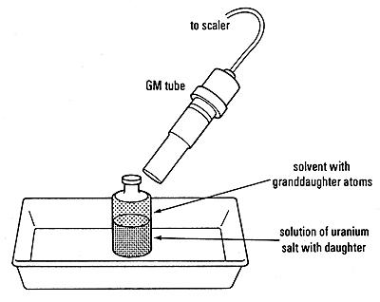
Alternatively, the G–M tube can be clamped horizontally with the window close to the upper layer.
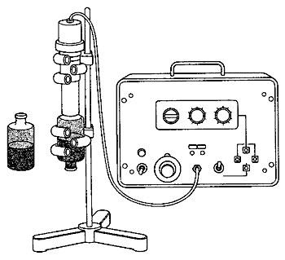
c Shake the bottle vigorously for about 15 s to mix the layers thoroughly.
d Place the bottle in the tray.
e As soon as the two layers have separated, start the count and start the stop-clock.
f Record the time from the beginning of the experiment (i.e. the “time of day” for the sample).
g Record the count every 10 s, or record it for 10 s every 30 s.
h Run the experiment for about five minutes – ample time to reveal the meaning of the term half-life and to illustrate the decay process.
i Provided that you leave a few minutes between each attempt, you can repeat the experiment. In five minutes the activity of the protactinium in the aqueous layer grows to 15/16 of its equilibrium value.
j It is possible to record the growth to equilibrium. Do this by moving the G–M tube so that the aqueous layer at the bottom of the bottle is immediately above the end window of the G–M tube.

Teaching notes
1 See The chemistry of the protactinium generator for an explanation of how it works.
2 Get the students to make a table of count rate against time, and correct it for background count. The first 10 s reading should be allocated to a time of zero.
3 Get the students to plot a graph of count rate against time. They should draw a smooth curve through the points.
First point out the general pattern – that the count rate decreases with time. Then look for an exponential trend – that the best-fit curve always takes the same amount of time to halve.
Get students to measure the half-life from the curve.
Point out the random nature of the points: although the decay follows a pattern, there is an element of randomness and it is not perfectly predictable.
4 “How science works” extension: This experiment provides an opportunity to assess the accuracy of the measured half-life value and how the random nature of decay affects the answer.
The commonly accepted value for the half-life of protactinium is 72 s.
Explore different ways in which a half-life value can be obtained from this apparatus:
• Amend the procedure described above so that, instead of a scaler (counter), a ratemeter is used. One student just records the time that it takes for the count rate to halve. This will provide a very approximate value.
• Repeat the experiment with several members of the class timing how long it takes for the count rate to halve. There is likely to be considerable spread in results across the group and the mean result may differ from the accepted value for half-life.
In each case, ask students to identify errors and uncertainties in their measurement(s) and to suggest ways in which these could be reduced.
For example, ask: “How does the random nature of the decay affect the measured count rate when the count is low, or high, compared with the background count?
• Either you or your students may suggest a graphical method as an improvement. The procedure described in the main experiment above could then be carried out and the accuracy of the half-life value assessed and evaluated.
Radioactive materials raise significant safety issues, providing an opportunity to discuss the value and use of secondary data sources.
This experiment was safety tested in February 2007.
Related guidance notes
- Managing radioactive materials in schools
- Developing a model of the atom: radioactive atoms
- Exponential decay of a radioactive substance
- Some useful equations for half-lives
- The chemistry of the protactinium generator

